Copy the crop_int folder to you documents directory
Take the classim.zip in “Executable for CLASSIM program” and right click on it, then choose ‘extract’.
You will get a dialog like this. If you choose the default, you will find the programs in another classim folder under this one. You can delete the ‘classim’ in the folder name and it will create a folder called ‘CLASSIM’ in the root of the directory you specify.
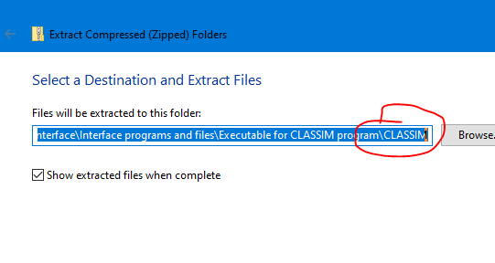
For example, you can change this to:
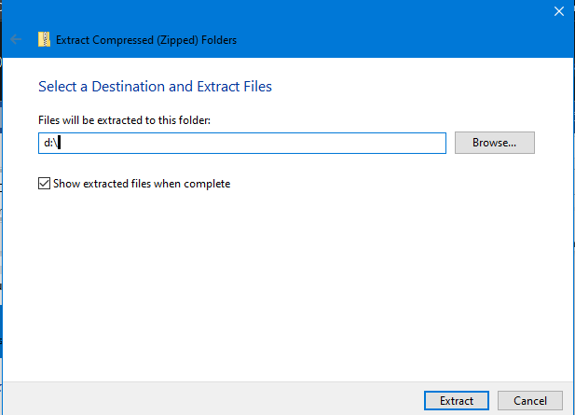
I usually put it in my D: drive but you can put it in your documents folder. It will put the extracted files in a folder d:\classim in this case
It takes up about a gig of disk so make sure you have space.
You should have a folder structure like this:
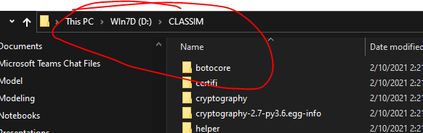
remember to open and command window and run the program from that. The program name is CLASSIM.exe
This is the program:
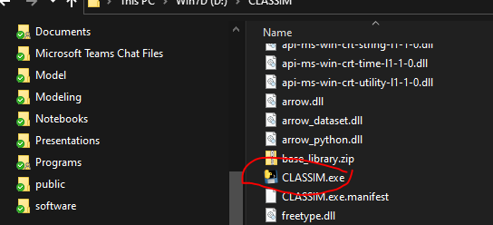

You can double click on it in file manager but the best way to run it is in a command window, that way you can see initial error messages.

Got to search in the taskbar: 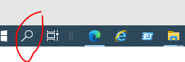
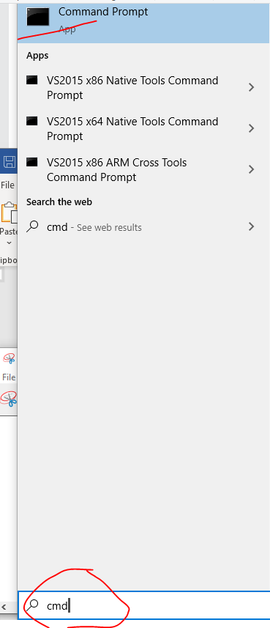
And search for ‘cmd’. Click on command prompt. Then you have to change to the folder where you installed classim. Say classim is in your documents folder, then do this
cd “c:\users\firstname.lastname\documents\classim”
Include the quotes, where firstname.lastname is your first and last names separated by a period. Now, sometimes the userfile is not exactly you first and last name. then you can use
cd “%userprofile%”
include the quotes. That should take you to your user profile. Then use
cd documents\classim
to go to the classim folder
run the program as
classim.exe
by entering this text on the line and hitting enter.

If your program is in the root of the d drive then you use
D:
On the command line to change to the disk. Then use the cd command to go to the folder with classim.

Running a simulation
Use the MANT simulations (from the excel file) to make up a new simulation in the interface.
use the ETBA and BEOU scenarios
When building a rotation select ETBA and BEOU for the first 3 items (Field, Soil and weather station). After selecting weather station, additional names will be available. These will be for weather_name and weather. Weather_name is a subset of the weather station. If CO2 or some of the parameters vary the weather_name will be different. Weather is a subset of weather_name. For example you may have different temperatures and/or rainfall for the same site and station parameters.

for the examples here choose ETBA_C and BEOU_C for the weather_name and weather.

Use add all to add the weather, field and soil data but not the treatment data. After adding these names, a second row will be created. select the row and then click clear. this will remove it. then select the treatment and drag it to the right. This will finish creation of the scenario and you can run it.

